Afrika
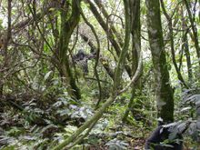
Mountain Gorillas, Bwindi Impenetrable National Park,
Uganda Hegyi gorillák, Bwindi Nemzeti Park , Uganda
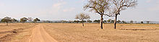

Mikumi National Park landscape Mikumi Nemzeti Park tájképi
- 1 Algeria
- 2 Angola
- 3 Benin
- 4 Botswana
- 5 Burkina Faso
- 6 Burundi
- 7 Cameroon
- 8 Cape Verde
- 9 Central African Republic
- 10 Chad
- 11 Comoros
- 12 Republic of Congo
- 13 Democratic Republic of Congo
- 14 Côte d'Ivoire
- 15 Djibouti
- 16 Egypt
- 17 Equatorial Guinea
- 18 Eritrea
- 19 Ethiopia
- 20 Gabon
- 21 The Gambia
- 22 Ghana
- 23 Guinea
- 24 Guinea-Bissau
- 25 Kenya
- 26 Lesotho
- 27 Liberia
- 28 Libya
- 29 Madagascar
- 30 Malawi
- 31 Mali
- 32 Mauritania
- 33 Mauritius
- 34 Morocco
- 35 Mozambique
- 36 Namibia
- 37 Niger
- 38 Nigeria
- 39 Rwanda
- 40 São Tomé and Príncipe
- 41 Senegal
- 42 Seychelles
- 43 Sierra Leone
- 44 Somalia
- 45 South Africa
- 46 Sudan
- 47 Swaziland
- 48 Tanzania
- 49 Togo
- 50 Tunisia
- 51 Uganda
- 52 Zambia
- 53 Zimbabwe

Ázsia
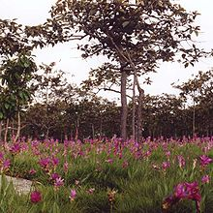

Pa Hin Ngam National Park , Thailand – Pa Hin Ngam Nemzeti Park, Thaiföld
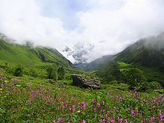

Valley of Flowers National Park, Uttarakhand, India
Valley of Flowers Nemzeti Park, Uttarakhand, India
- Brunei
- China
- Republic of China (Taiwan)
- Hong Kong
- India
- Indonesia
- Iran
- Israel
- Japan
- Kazakhstan
- Korea
- Malaysia
- Mongolia
- Nepal
- Pakistan
- Philippines
- Russia
- Singapore
- Sri Lanka
- Thailand
- Vietnam

Európa
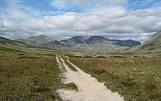
Rondane National Park, Norway – Rondane Nemzeti Park , Norvégia

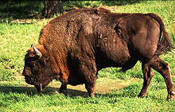
A wisent in the Białowieża Forest, Poland – Bölény a Bialowieza Erdőben, Lengyelország

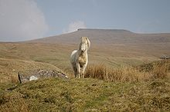
A Welsh Mountain Pony in the Brecon Beacons, National Park, Wales
A walesi hegyi póni a Brecon Beacons National Park, Wales

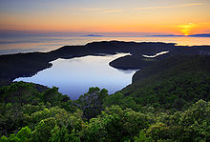
A sunset over the lakes in Mljet National Park in Croatia
Naplemente a Mljet Nemzeti Parkban, Horvátországban
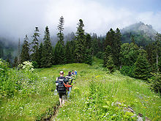
Borjomi National Park in Georgia is one of the biggest in Europe
Borjomi Nemzeti Park Grúziában, az egyik legnagyobb Európában
- Albania
- List of national parks in the Alps
- Austria
- the Baltics
- Belarus
- Belgium
- Bosnia and Herzegovina
- Bulgaria
- Croatia
- Czech Republic
- Denmark
- Estonia
- Finland
- France
- Georgia
- Germany
- Greece
- Hungary
- Iceland
- Ireland
- Italy
- Kazakhstan
- Latvia
- Lithuania
- Liechtenstein
- Macedonia
- Malta
- Montenegro
- Netherlands
- Norway
- Poland
- Portugal
- Romania
- Russia
- Serbia
- Slovakia
- Slovenia
- Spain
- Sweden
- Switzerland:
  - Swiss National Park
  - Parc Ela
- Turkey
- Ukraine
- United Kingdom
  - England and Wales
  - Northern Ireland
  - Scotland

Észak-Amerika / Karib-térség
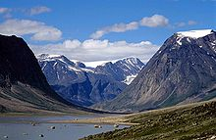

Auyuittuq National Park, Canada – Auyuittuq Nemzeti Park, Kanada
- Bahamas
- Canada
- Dominica
- Dominican Republic
- Guadeloupe: see France
- Greenland:
  - Northeast Greenland National Park
- Haiti
- Mexico
- United States

Közép-Amerika
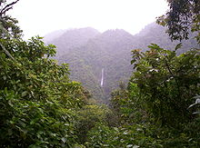

Tapanti National Park in Costa Rica – Tapanti Nemzeti Park Costa Rica.
- Costa Rica Costa Rica
- Guatemala Guatemala

Dél-Amerika
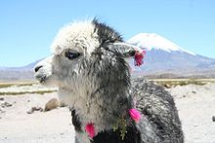
A pet alpaca at Lauca National Park, Chile – Kedvtelésből tartott alpaka a Lauca Nemzeti Park, Chile
- Argentina Argentína
- Bolivia Bolívia
- Brazil Brazília
- Chile Chile
- Colombia Colombia
- Ecuador Ecuador
- Guyana Guyana
- Peru Peru
- Venezuela Venezuela

Ausztrália és Óceánia
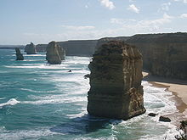
Twelve Apostles in Port Campbell National Park, Victoria, Australia
Tizenkét Apostol a Port Campbell Nemzeti Park, Victoria, Ausztrália .
- Australia Ausztrália
- Hawaii: see United States Hawaii: lásd az Egyesült Államok
- Fiji Fidzsi-szigetek
- New Zealand Új-Zéland

